Personal Portfolio

Student Name：Chaosheng Jiang

Student Number：N9298690

I am a member of Team 5 and it has been 10 weeks since our team built up. I am an IS student and there a 4 CS students in my team. In the following paragraph, several different artefacts which I will be shown

**① I focused on two user stories.**

User story 1



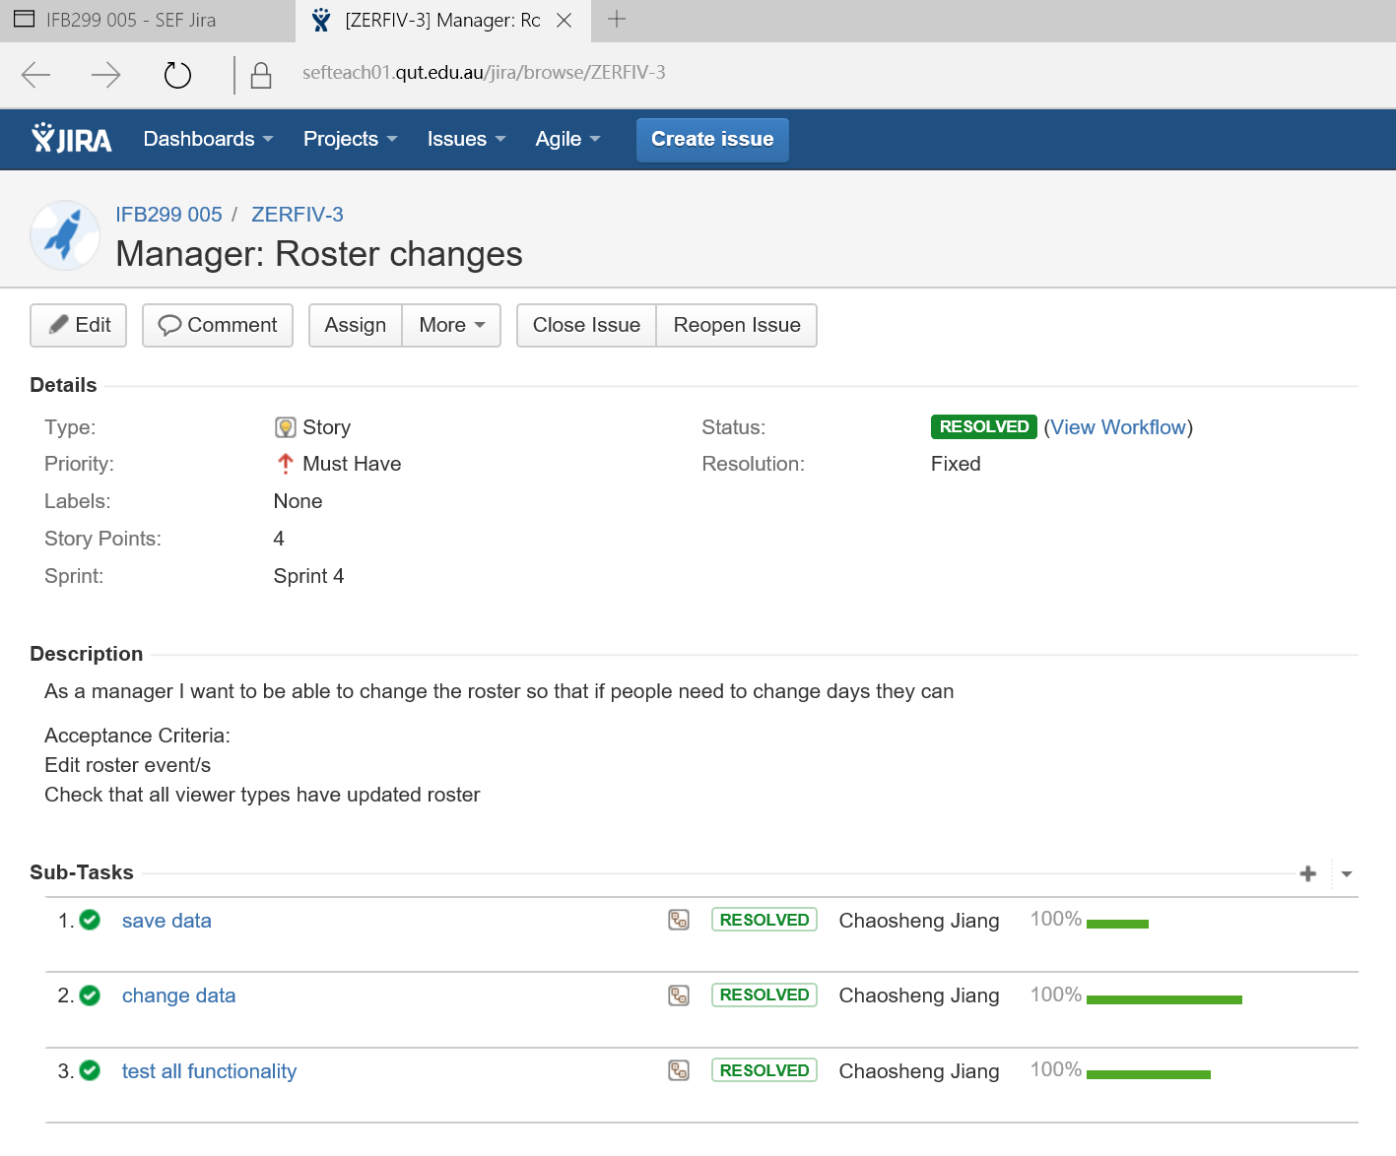

User story 2

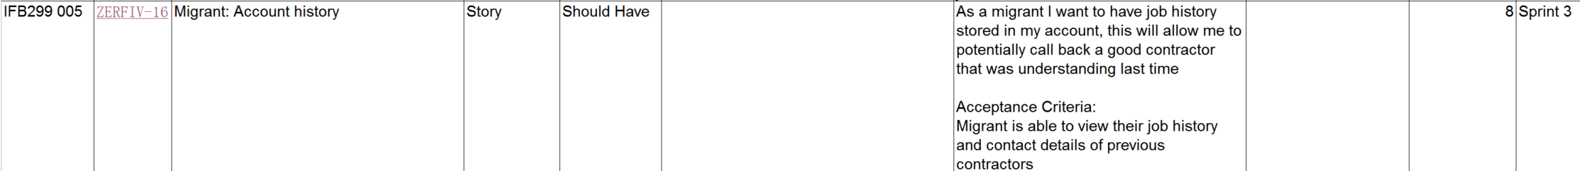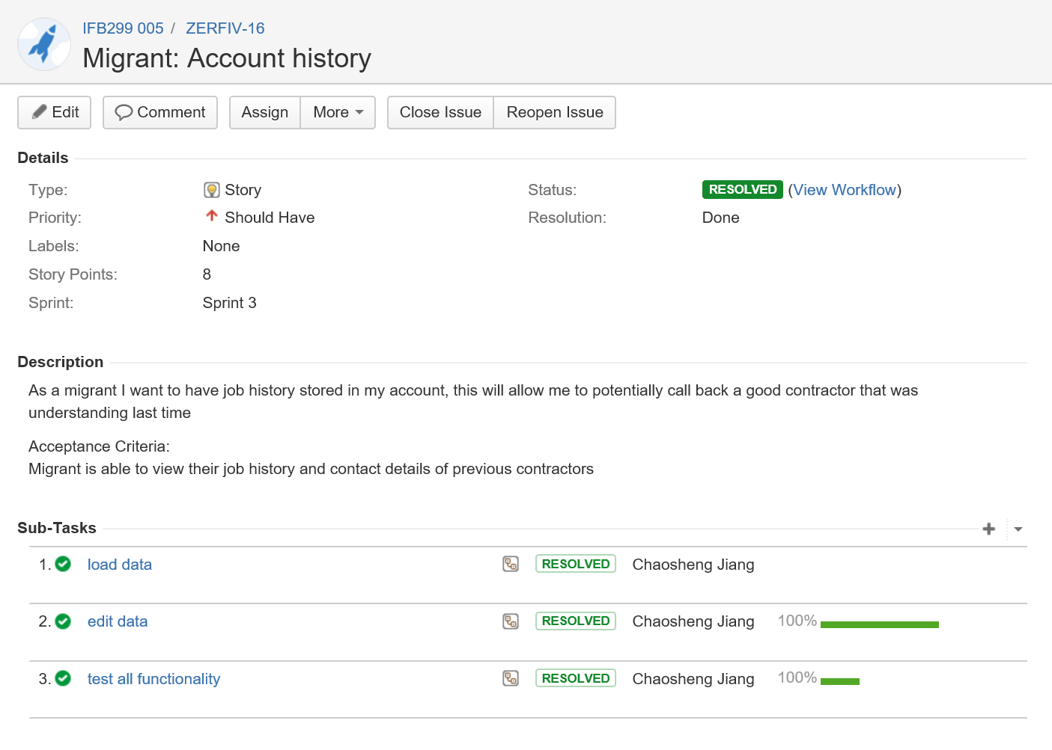

**②Test some parts of the website**.

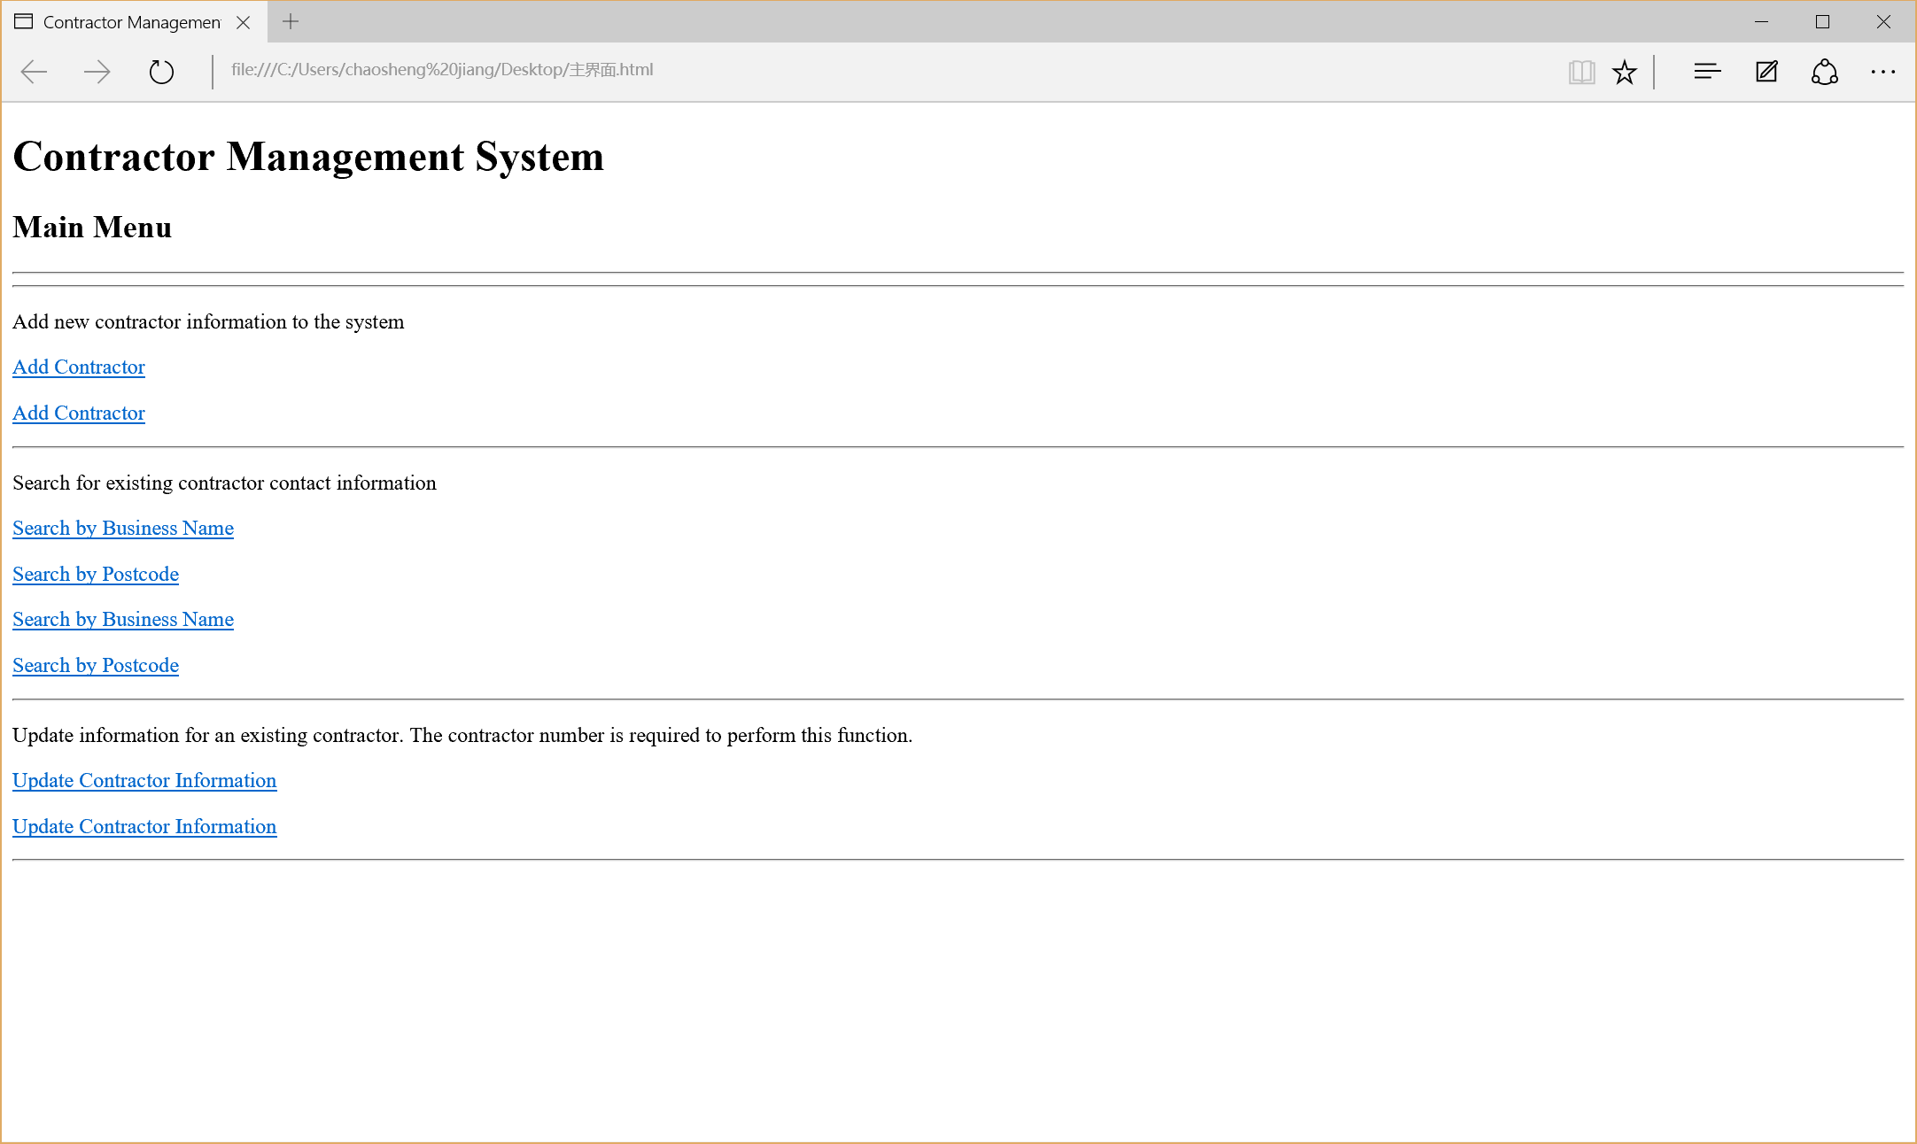

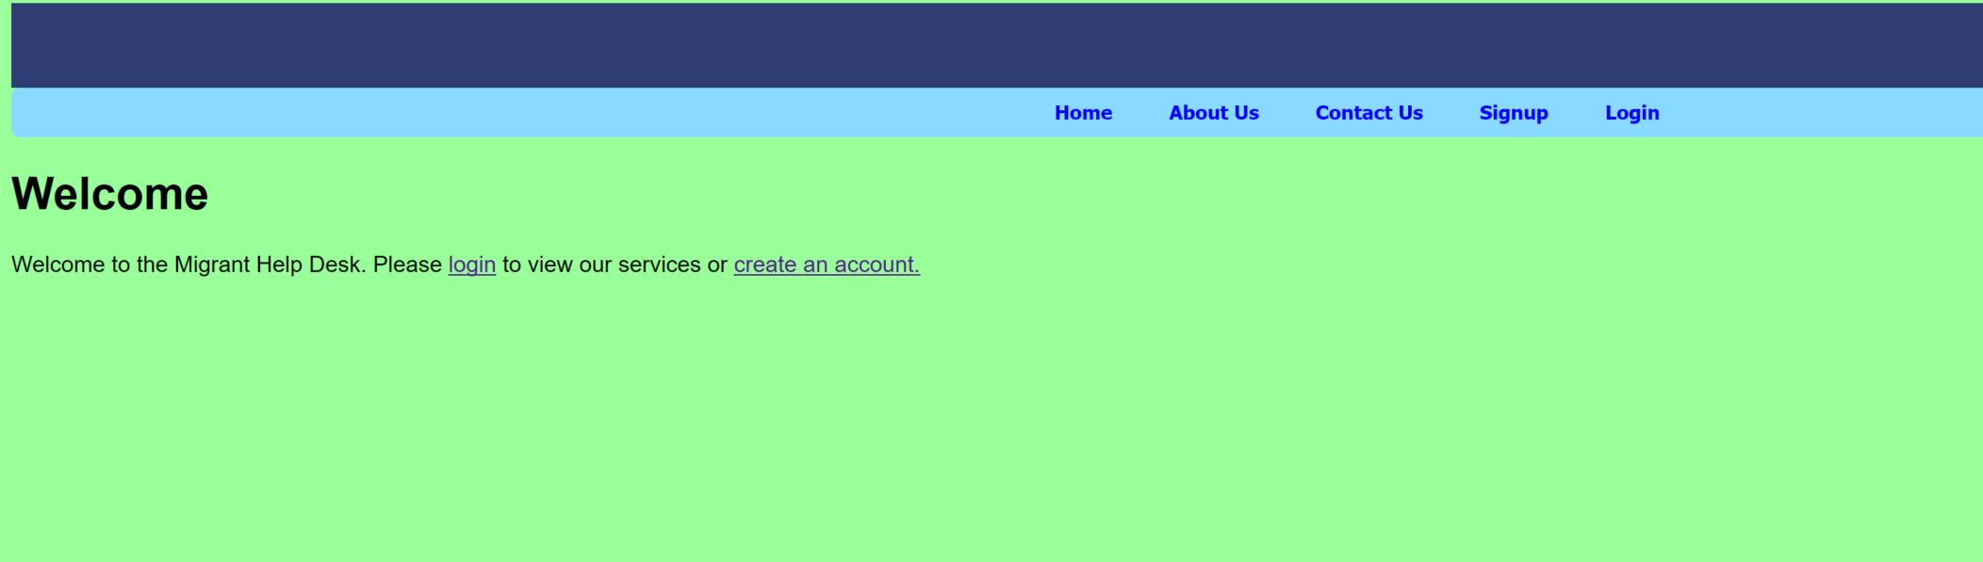

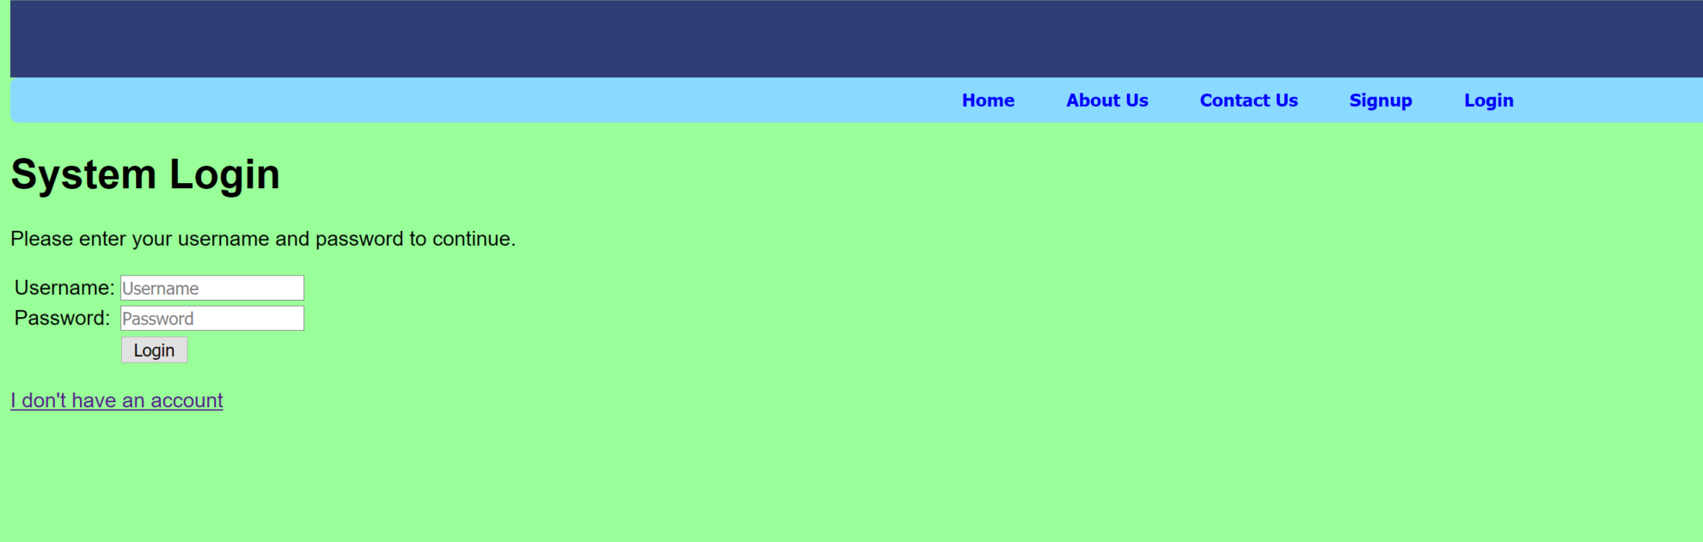

These are all well test and no error found.

**③Write some parts of release and sprint plan**

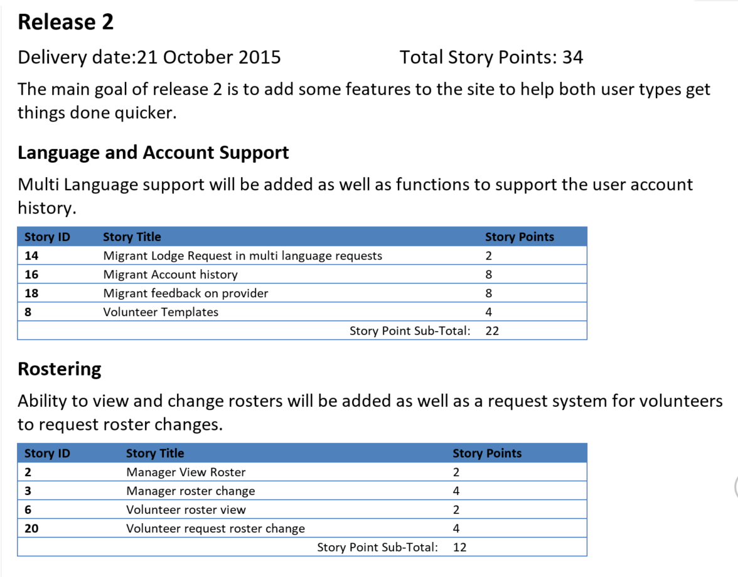

This is the release I focused on

**④Collect the clients’ requirements.**

We have many meeting with our clients and everytime we finished the meeting, our clients gave us some requirements. Then, I arrange these requirements and assign these to different group members who focused on.

**⑤Give some suggestions to page design**

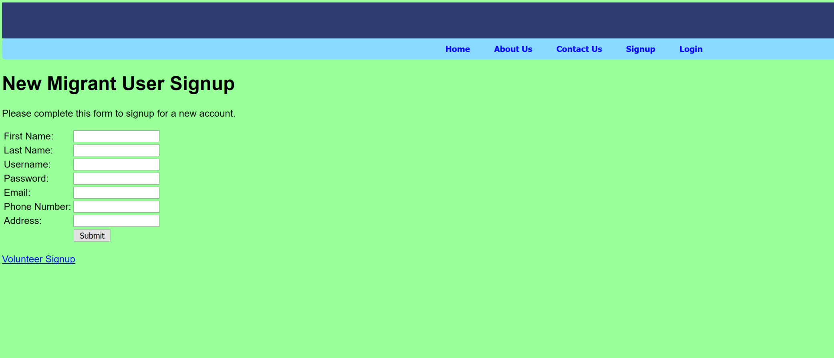

I designed the page color and the order of the characters and I think this page is simple but concise.　Additionally, this page is very easy for clients to use and meet their requirements.